CSS Resource

<https://developer.mozilla.org/en-US/docs/Web/CSS>

Css are of three types and they are :

1. Inline

1. Internal

1. External

Css selectors

1. Class selector
2. Id selector
3. Attribute selector

1 represent the width, 2nd represent sides and 3 represent color

In order to convert inline to block level element or vice versa you can use css like this

**Placeholder**

As shown whenever you click on username it will be redirected to the corresponding input field.

Other input types

<https://developer.mozilla.org/en-US/docs/Web/HTML/Element/input#input_types>

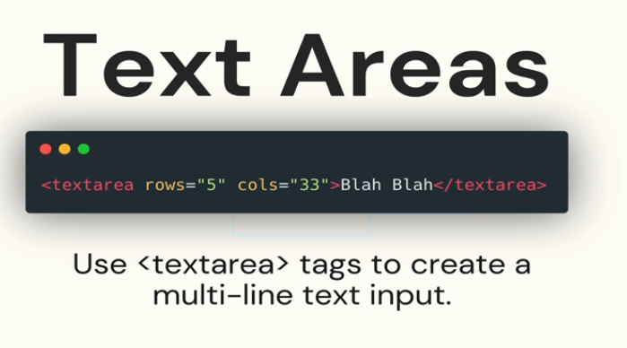

Semantic Element

<https://developer.mozilla.org/en-US/docs/Glossary/Semantics>

Detail tag gives a kind of arrow navigation symbol by clicking on that we can hide and show the content.

Difference between em px and rem



